EMG signal extraction and application for exoskeleton control.

Dinesh Patil, Ritika Inamke, Anubhav Gupta
Dept. of Electronics and Telecommunication,
MAEER’s MIT College of Engineering,
Pune, India.
dineshpatil2392@gmail.com, ritikainamke.11@gmail.com, anubhav96gupta@gmail.com

Abstract— The aim of the paper is to throw light on the concept of EMG signals and how they can be applied to real world applications such as muscle rehabilitation through the employment of a motion support exoskeleton. Another important concept requiring consideration is the relation between the EMG signal observed and the actual torque applied by the muscle. The various elements of such an EMG system are discussed in brief providing a general idea of the application for EMG signal monitoring and exoskeleton control.

Index Terms— EMG signals, exoskeleton, muscle rehabilitation, EMG-torque relationship, EMG extraction, Biomedical signal noise considerations.

- INTRODUCTION
- EMG signal

The EMG signal is a measure of the electrical activity of the muscle. The electrical activity is the result of a signal generated in the brain which is transmitted through the nervous system to the motor neuron attached to the muscle fibers in the muscle. The motor neuron fires resulting in a depolarization/ repolarization wave throughout the muscle fiber. This wave creates an action potential in the muscle fibers resulting in the movement of electric charges. This electrical activity produces an electric signal in the muscle which can be picked up by well-placed electrodes on the surface of the skin. The acquired signal is called the Electromyogram (EMG) signal.
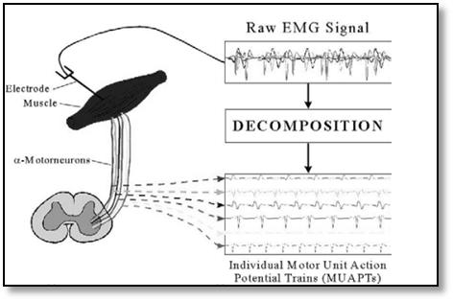

Fig. 1. Raw EMG signal obtained from the muscle capturing the MUAP responses.
This raw EMG signal consists of a series of spikes whose amplitude depends on the amount of force delivered by the biceps – the stronger the contraction of the muscle, the larger the amplitude of the EMG signal. The frequency of the spikes is the firing rate of the motor neurons. Since the amplitude of the EMG signal is directly related to the force exerted by the muscle, it is used to determine the force signal sent to the exoskeleton.
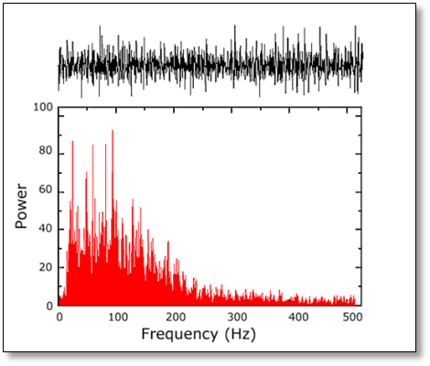
Fig. 2. EMG signal and its general
frequency response.

- Surface EMG

Various types of techniques for obtaining the EMG signal are available. Clinically the use of needle electrodes is suggested however they are invasive techniques and hence impractical and uncomfortable for a portable application such as general amplitude measurement for exoskeleton control. Hence the use of surface electrodes is applied for this purpose. The most obvious advantage is the ease of application, no need of medical supervision due to its non-invasive nature and good accuracy achievable with proper precaution. The crucial factors needed to be taken into consideration for Surface EMG (SEMG) are:
- Skin preparation.
- Electrode placement.
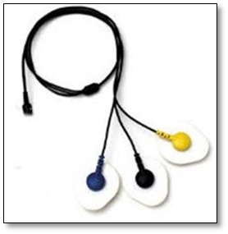
Fig. 3. Surface electrodes for measuring
the EMG signal.

- Relation between EMG signal and muscle torque

The relation of surface EMG to torque makes EMG an attractive alternative to direct muscle tension measurements, necessary in many physical assessments. However, the complexity of the EMG signal origin has been a barrier for developing a quantitative description of this relation. The EMG signal origin and character is necessary background to understand the difficulty of establishing a relationship between surface EMG and torque.

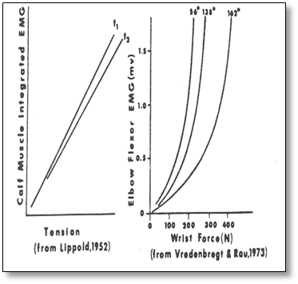
Fig. 4. Relation between EMG signal and muscle tension and force(N)

There are many applications that the tension exerted by the muscle group during the various activities is useful, however direct measurements are unnatural, invasive, expensive, and they may also not be possible presently.
A relation between EMG and torque simplifies the situation, because EMG is readily obtained by either surface or wire electrodes depending upon whether the muscle group or individual muscle measurements are needed.
Studies of the relationship between surface EMG and force have found that there exist both linear and non-linear relationships. The degree of linearity is dependent on the muscle being investigated, but other factors must be also considered. Characteristics of the muscle of interest may also influence the EMG to torque relationship. Muscles of uniform fiber composition exhibit a linear relationship while a random non-even composition of fibers behaves more nonlinearly. Furthermore, the muscles display nonlinear behavior at lower torque levels due to selective recruitment of motor units at different distances from the electrodes.
As a summary, the concept of torque for the skeletal muscles is derived from the motion of the bones about a joint due to muscle contractions. Since surface EMG signal measures the activity of the skeletal muscles, a mathematical relationship can be established between the EMG amplitude and net joint torque.

- Exoskeleton

An exoskeleton is a supporting structure on the outside of a body. The name stems from the words exterior and skeleton. The design of this exoskeleton takes its controlling signal from EMG electrical signals in the biceps muscle. The amplitude of this EMG signal is directly related to the amount of force delivered by the biceps. From this amplitude we can make a close determination of the force delivered by the biceps and translate this force into the torque which can then be sent to the exoskeleton actuator – the servo motor. In this manner, the exoskeleton will assist in bearing a load on the human arm. This exoskeleton will provide the needed support in lifting movement of the arm and can be similarly applied to other muscles as well. The aim of developing this exoskeleton is to provide a structure in aiding the physiotherapy and muscle rehabilitation of an individual.

- EXTRACTION

Surface electromyography (SEMG) is widely used for experimental purposes and gives satisfactory results. The quality and fidelity of the signal acquired depends on various factors most importantly on the placement of electrodes. The electrode should be placed between a motor point and the tendon insertion or between two motor points, and along the longitudinal midline of the muscle. The longitudinal axis of the electrode (which passes through both detection surfaces) should be aligned parallel to the length of the muscle fibers.

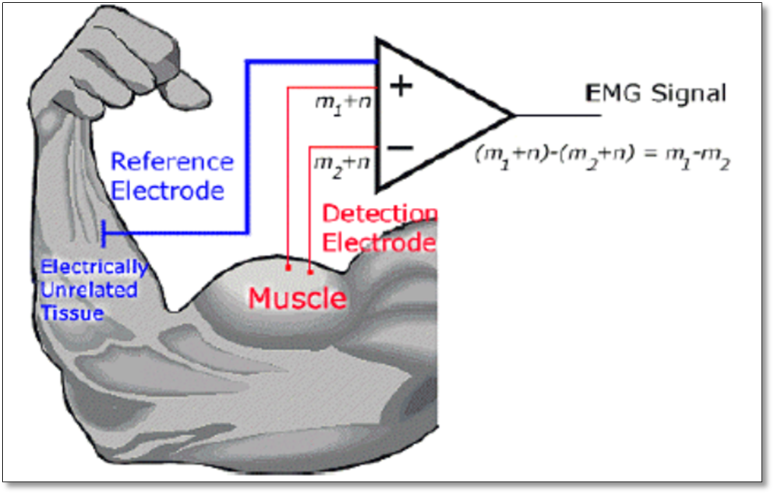
Fig. 5. EMG extraction using a differential amplifier with the help of reference electrode.

The common design of SEMG sensors consists of an arrangement of two electrodes placed in proximity, each detecting a potential on the skin. The two potentials are subtracted and amplified, providing a single differential signal, which is more sensitive to the local potentials on the muscle than those originating farther away. The reason for differential amplification is that any signal that appears common to both the electrodes (eg. noise) will be removed.
The reference electrode (at times called the ground electrode) is necessary for providing a common reference to the differential input of the preamplifier in the electrode. For this purpose, the reference electrode should be placed as far away as possible and on electrically neutral tissue (say over a bony prominence).The electrode – skin interface generates a D/C voltage potential, mainly caused by a large increase in impedance from the outermost layer of skin, including dead skin material and oil secretions. This D/C potential, common to all electrodes, can be minimized with proper skin preparation.
It is desirable to obtain maximum information from the extracted EMG signal with minimum contamination of noise. Because the power line sources (50/60 Hz) are a major noise contributing factors, most design systems tend to include notch filters. The notch filter tends to remove not only 50Hz noise but also the adjacent frequency components. Since EMG signal has maximum energy content in 50-150Hz region, use of notch filter is not a good practice.
The signal is pre-amplified using an instrumentation amplifier made up of Texas’s TL064 IC with an initial gain of 41. The signal is then filtered by 4th order low pass and high pass Butterworth filters.

- NOISE CONSIDERATIONS

The ambient noise plays a major role in measuring EMG signal. It originates from sources of electromagnetic radiation, such as radio and television transmission, electrical-power wires, light bulbs, fluorescent lamps, etc. The surfaces of our bodies are constantly inundated with electric-magnetic radiation and it is virtually impossible to avoid exposure to it on the surface of the earth. Hence the quality of the electrodes and amplifier design must be given special attention in order to compensate the ambient noise. The amplitude of the EMG signal is quasi-random in nature. The frequency components between 0 and 20 Hz are particularly unstable because they are affected by the quasi-random nature of the firing rate of the motor units which, in most conditions, fire in this frequency region. Because of the unstable nature of these components of the signal, it is advisable to consider them as unwanted noise and remove them from the signal. There are two main sources of motion artifact: one from the interface between the detection surface of the electrode and the skin, the other from movement of the cable connecting the electrode to the amplifier. Both of these sources can be essentially reduced by proper design of the electronic circuitry.
The electrode stability is another concern. When an electrode is placed on the skin, the detection surfaces come in contact with the electrolytes in the skin. A chemical reaction takes place which requires some time to stabilize, typically in the order of a few seconds if the electrode is correctly designed. But, more importantly, the chemical reaction should remain stable during the recording session and should not change significantly if the electrical characteristics of the skin change from sweating or humidity changes.
It is important to recognize that the bipolar SEMG is not always a selective representation
of the electrical activity of a single muscle directly underlying the recording electrodes. With smaller muscles the electrodes may overlook the electrical activity of one or more neighboring muscles and their signals may interfere with the SEMG from the desired muscle. The width and length of the detection surfaces must be decided according to the desired muscle signal. Larger electrodes are susceptible to interference from adjacent muscles. In this case, the electrode size and the inter-electrode distance must be reduced so as to capture only the intended EMG signal.
The signal-to-noise ratio (SNR) can be greatly increased by accurate design of the instrumentation amplifier. The input impedance of the amplifier must be very high in order to match the skin impedance. The CMRR is the first specification to be considered while judging the performance of the amplifier. It should be large enough to reduce the common mode noise and amplify the required EMG signal. The muscle signal is very low (in the order of a few millivolts). The offset introduced by the amplifier if dominant, the signal of interest might be lost. Thus, it is very important to reduce the AC/DC offset introduced by the amplifier so as to maintain the integrity of the signal.

- APPLICATION
  - Computer Interface for signal monitoring.

With the current technology, computer provides the best interface between any system and the human user. Similarly, the EMG signal can be reproduced graphically to the user or physician undertaking the EMG measurement using a Graphical User Interface(GUI) over many simulation and measurement tools available. Here, LabVIEW GUI has been used for the graphical representation of the EMG signal as a function of time to the user. Furthermore additional analysis and digital filtering can be achieved using LabVIEW program to enhance the details and
understand the intricate nature of the EMG signal as it varies along time and under various test conditions.

  - Exoskeleton for muscle rehabilitation support

In physiotherapy often external exoskeleton structure is employed to help exercise and rehabilitate an injured muscle. An active exoskeleton not only provides support but also operates on the EMG signal amplitude thus providing actual response of the recovery of the patient as well as providing unsupervised exercise for physiotherapy.

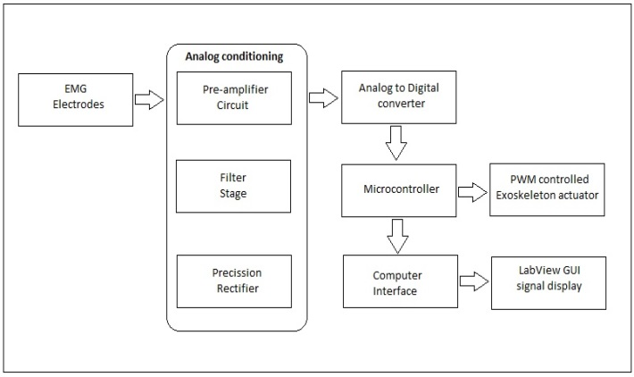

Fig. 6. System design for general EMG monitoring and exoskeleton control system.

- CONCLUSION
The study of EMG signal has been a topic of discussion which has gained quick attention. Extracting and analyzing the signal are the important tasks to be carried out. We presented in this paper how to extract EMG signal to get accurate information and the noise reduction techniques to be considered while designing the system. Many EMG testing and measurement systems available in the market are quite expensive. Cost effective systems if built and applied to exo-skeleton can help greatly in the field of rehabilitation.

REFERENCES
[1] ‘The ABC of EMG’, A practical introduction to Kinesiological Electromyography, Peter Konrad.

[2] ‘Techniques of EMG signal analysis: detection, processing, classification and Applications’, M. B. I. Reaz,1* M. S. Hussain1 and F. Mohd-Yasin1.

[3] ‘Surface Electromyography’ –Carlo J.De Luca, Delsys.

[4] ‘Important Factors in Surface EMG Measurement’- Dr. Scott Day, Bortec Biomedical.

[5] ‘A Myosignal -Based Powered Exoskeleton System’, IEEE TRANSACTION ON SYSTEMS, MAN, AND CYBERNETICS—PART A: SYSTEMS AND HUMANS, VOL. 31, NO. 3, MAY 2001.

[6] Inter-electrode spacing of surface EMG sensors: Reduction of crosstalk, contamination during voluntary contractions- Carlo J.De Luca, Mikhail Kuznetsov , L.Donald Gilmore, Serge H. Roy.

[7] Standards for Reporting EMG Data: Dr. Roberto Merletti, Politecnico di Torino, Italy.

[8] Design of an Arm Exoskeleton Controlled by the EMG Signal-Mark Novak, Cornel College PHY312.

[9] Application of Surface Electromyographic Signals to Control Exoskeleton Robots -R. A. R. C. Gopura and Kazuo Kiguchi.

